Social Media Analytics - Assignment 1

Vishwa Bhuta, Emily Graves, Ryan Maas, Caroline Nelson, and Jon Zeller

*February 8, 2017*

Edmunds Forum

We used the forum on Edmunds that discusses entry level performance luxury sedans (link below).  This is the same forum that was discussed during in-class examples.  This forum was a great candidate due to the high number of comments on the post.  The scraper we built pulled messages from the first 600 pages of the forum, which resulted in approximately 18,000 messages.

<https://forums.edmunds.com/discussion/2864/general/x/entry-level-luxury-performance-sedans>

Top Brands

The top 10 brands were determined by counting the number of reviews a brand appeared in (1 count per review). The top 10 brands were determined to be BMW, Acura, Audi, Honda, Infiniti, Toyota, Nissan, Volkswagen, Mercedes-Benz, and Ford. The frequency of the top 10 brands can be found in Table 1, and the lift calculations and MDS map can be found in Table 2 and Figure 1, respectively.

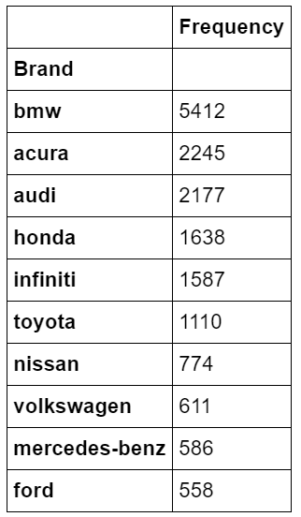

Table 1: Top 10 Brands

*Lift Calculations*

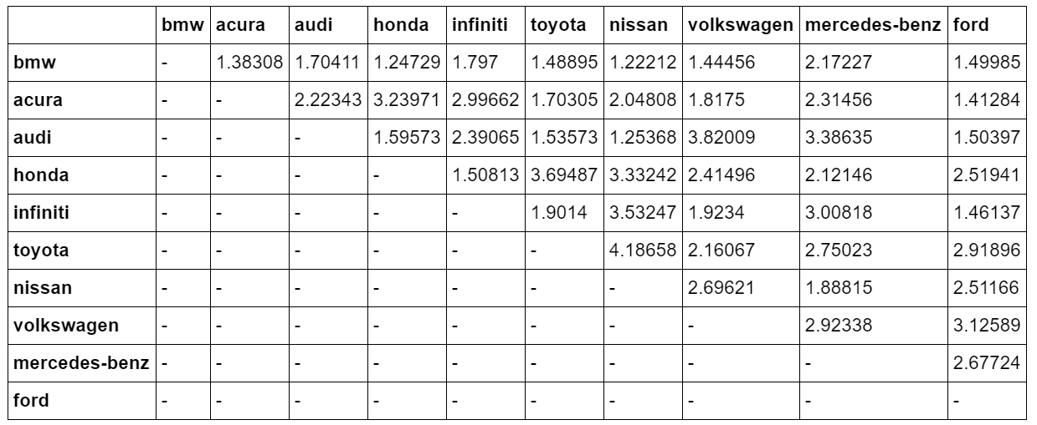

Table 2: Lift Calculations between Top 10 Brands

*MDS Map*

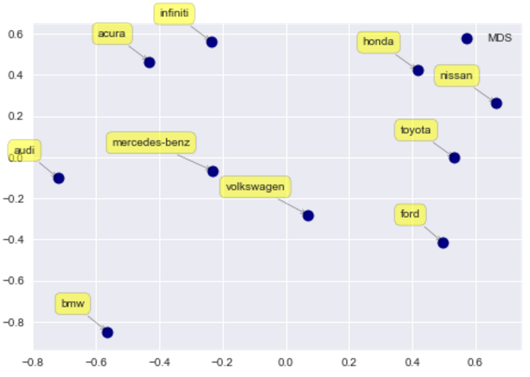

Figure 1: MDS Map of Top 10 Brands

*Insights:*

From this MDS chart, we can see that Acura and Infiniti are often compared to each other.  That being said, customers may be likely to switch between the two brands. We can also see the three major Japanese value brands - Honda, Nissan, and Toyota - all located near each other and away from the European luxury brands (BMW, Audi, etc.).

Top 5 Attributes

*Brand/Attribute Lift*

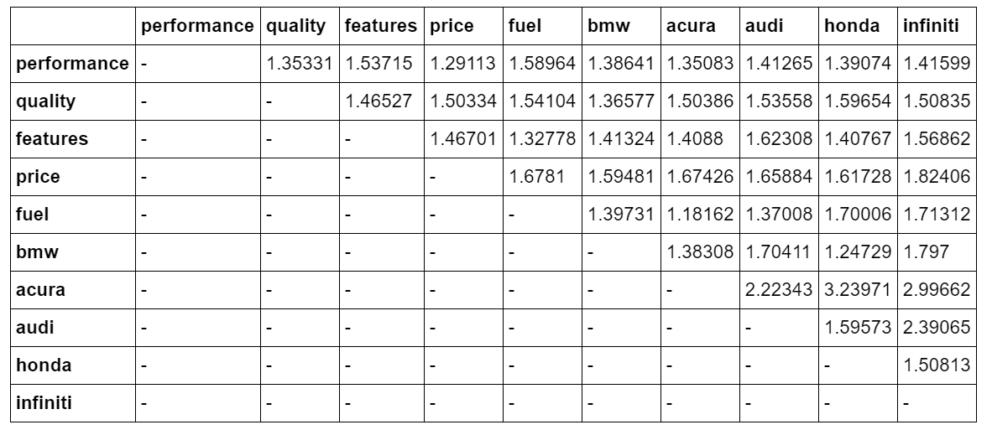

Table 3: Lift Calculations between Top 5 Features and Top 5 Brands

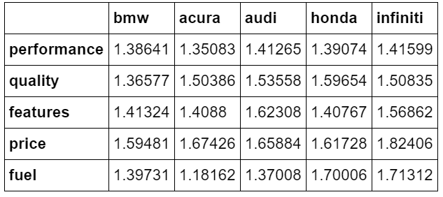

Table 4: Lift Calculations between Top 5 Features and Brands (condensed)

Given only these lift scores, we cannot know the sentiment associated with the attributes.  If we were to assume a positive sentiment, it seems that customers would associate high performance with Infiniti, high quality with Honda, diversity of features with Audi, good price with Infiniti, and fuel efficiency with Infiniti.   If a brand has a high lift score with any of these attributes, the advertising/marketing manager could reiterate these attributes in campaigns or promotions.  The low lift scores of fuel, features, quality, or performance could alert the product manager that those areas need improvement.

Another way an advertising manager could use this information is to compare itself to a similar brand and exploit its strengths over the similar brand.  For example, in the lift chart and MDS map we saw that Acura and Infiniti were often compared together in messages.  For an advertising manager at Infiniti, they could capitalize on this by targeting their ads comparing themselves to Acura and all of the ways they are superior.  According to the attribute lift scores in Table 4, Infiniti is more often described by performance, quality, features, and fuel.  Assuming positive sentiment, this is a great way for promoting your own product and differentiating yourself to customers who are choosing between the two brands.

Aspirational Brand

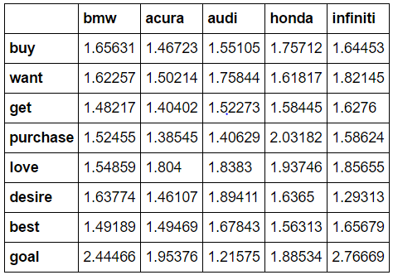

Table 5: Lift Calculations between top 5 brands, and list of ‘aspirational’ words

We compiled a list of words that implied both intentionality (‘buy’, ‘purchase’) and aspiration (‘goal’, ’desire’), and looked at how often those words are mentioned with our top brands. The chart reveals an interesting, albeit unsurprising, finding. When we look at words that are more action-oriented, Honda has the highest lift, such as its 2.03 lift with ‘purchase’. Considering that Honda also has a high lift with ‘love’, a marketer could ascertain that perhaps Honda has hit a “sweet spot” - a balance between price, performance, features, reliability, etc. that makes customers actually love and want to purchase this brand over others. When we look at words which express pure desirability, Audi and Infiniti have higher lifts, such as with ‘desire’, ‘best’, ‘want’. These results make sense, as Honda is a value brand that people are more likely to discuss actually purchasing, whereas Audi is more like the brand people wish they could have. However, given the fact that Infiniti also has a fairly high lift with intentionality words, such as ‘get’ and ‘buy’, combined with its lift with desire words, we can conclude that Infiniti is the most aspirational brand that is backed by intention.

Advice and Insights

Without sentiment analysis techniques, lift calculations only serve to show us which topics are frequently mentioned together, with no indication of the associated positive, negative, or neutral sentiments. As such, when looking at brands, we are able to form a picture of the competitive landscape but not make any conclusions about the directions of preference. Looking at the MDS plot, it is interesting to note the three Japanese brands of Toyota, Honda, and Nissan essentially living in their own cluster. Based on lift with other brands, we can conclude that these brands are mentioned in similar contexts, implying they are viewed similarly. On the other end of the two-dimensional space are luxury brands like BMW and Audi. This implies that the public does not view these brands as similar to the Japanese brands, which would probably be viewed as a win for marketers from both sides. Also of particular note is the location of Ford in the projected MDS space - relatively isolated but closest to the Japanese trio, and located far away from luxury brands. Ford is likely attempting to compete in the same space as Japanese brands - affordable, reliable, and made for the normal consumer - but based on consumer perceptions, it still has a way to go.